Turkish Society of Orthopaedics and Traumatology

2010 discounted subscription rate for The Journal of Bone and Joint Surgery

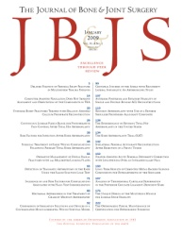
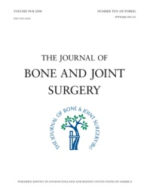
This world leading orthopaedic journals package is essential reading for general as well as specialist orthopaedic surgeons worldwide. JBJS is delighted to offer TOTBID members a 15% discount on the combined volume subscription, either in print or DVD format, during 2010.
The subscription package consists of both British and American Volumes and includes:
- 24 issues a year of the highest quality international research and leading reviews
- Full online access across both journals with latest articles in both PDF and HTML format
- Educational tools and features, including CME, Instructional course lectures, informed opinions from leaders in the field, reading lists by subjects, journal club reports, RSS feeds by specialty, podcasts and videos
- 6-7 free supplements a year of JBJS (Br)’s Orthopaedic Proceedings (published abstracts from major society and association meetings) and JBJS (Am)’s Surgical Techniques (popular video demonstrations of key surgical techniques)
JBJS selects articles for publication using first class peer review and rejection rates for these journals are 80-85%. Both volumes are highly cited, with half lives over 10 years and impact factors ranked within the top 10 in Orthopaedics (Thomson Scientific Journal Citation Reports).

Please complete and return the order form to take advantage of this special rate.

Consultants - 15% off • Trainees - 50% off

TOTBID Discounted Order Form 2010
Please complete this form and post to: Subscriptions , JBJS, 22 Buckingham Street, London, WC2N 6ET, UK
Or Fax to: +44 (0)20 7451 0929

I am a member of TOTBID and my membership number is: ___________________________________________

I would like to subscribe to:
Consultant – 15% off Trainee – 50% off
Print & online of the Combined Volume (24 issues) €225.68 / £154.70 €132.75 / £91.00
DVD & online of the Combined Volume (Quarterly) €225.68 / £154.70 €170.00 / £116.50

I am a trainee and I have included a letter from my head of training

Please start my subscription from: January 2010 The next issue

Full Name: ___________________________________________________________________________

Delivery & Billing Address: ______________________________________________________________

_____________________________________________________________________________________

Country: _________________________________ Telephone: ________________________________

Email: _______________________________________________ Sign me up for FREE Table of Contents alerting

Method of Payment

I enclose my cheque for ____________ (Please make cheques payable to ‘The Journal of Bone and Joint Surgery’ in £ Sterling or Euros.)
Or please debit my: Visa Mastercard Amex (circle one)
(Credit card payments will be processed in UK Pounds using the prevailing exchange rate on the day of processing.)
Account number: __ __ __ __ / __ __ __ __ / __ __ __ __ / __ __ __ __

Security Code: __ __ __ __ Expiry date __ / __ Total: £
Signature
- Please keep me informed by email of relevant publishing items, news and special offers from the British Editorial Society of Bone and Joint Surgery. We may provide the names, postal and email addresses of subscribers to our companion journal, The American Volume of the Journal of Bone and Joint Surgery. We do not sell names and addresses to third parties and you may remove your name from our mailing list at any time by emailing unsubscribe@jbjs.org.uk.

